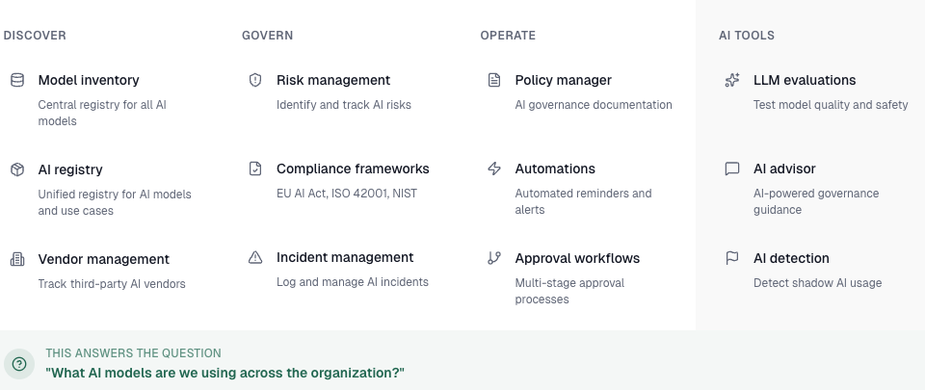
Model Inventory
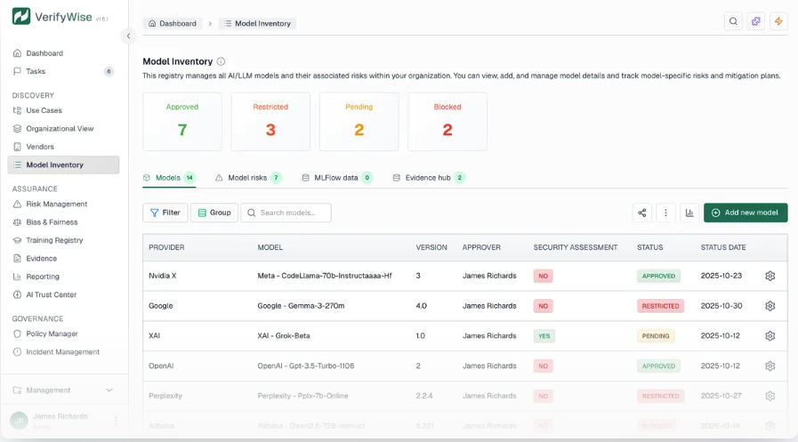

Register every AI system with unique UC-IDs, risk classification, stakeholder assignment, and automatic compliance framework linkage.
Use case-general view

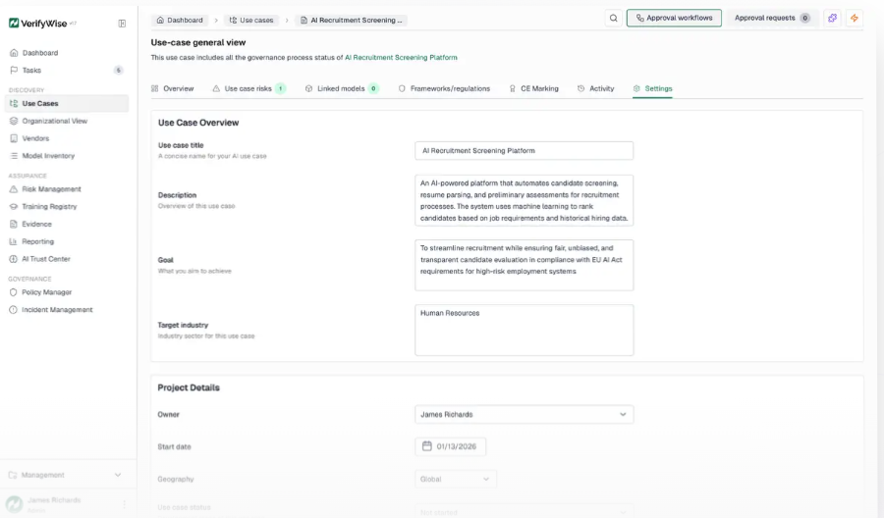
Track third-party AI vendors and their compliance posture
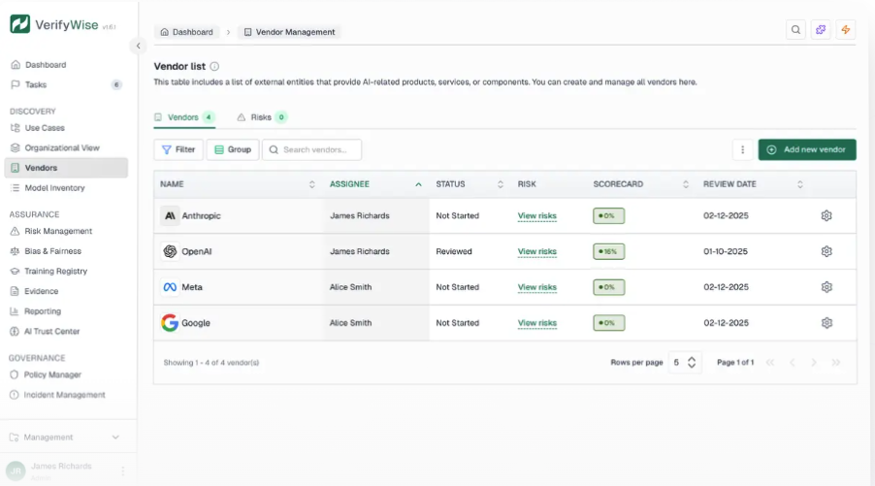
Monitor your AI vendor ecosystem with structured risk assessments, review workflows, and compliance verification across multiple regulatory frameworks.

Turn AI risk from a blocker into a competitive advantage
A structured approach to identifying, assessing, and mitigating AI risks across your organization—with full traceability to compliance frameworks.

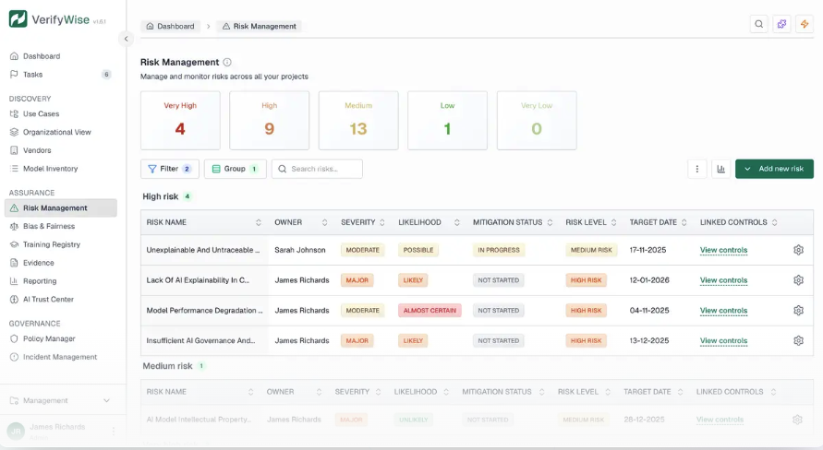

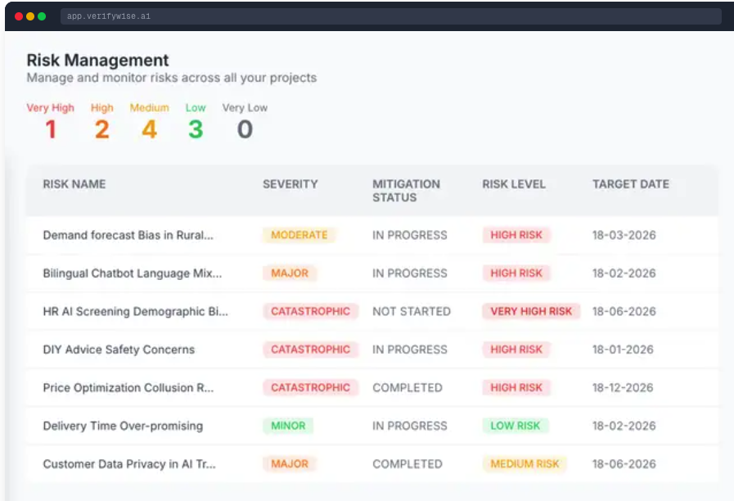

Pre-built frameworks for EU AI Act, ISO 42001, ISO 27001, and NIST AI RMF with structured workflows, evidence collection, and real-time progress tracking.
Why use Compliance frameworks?
Organizations deploying AI now face a patchwork of regulations and standards: EU AI Act, ISO 42001, ISO 27001, NIST AI RMF, and more on the horizon. Each framework has different structures, terminology, and requirements. Managing compliance across multiple frameworks manually leads to duplication, gaps, and audit surprises.
Key advantages for your AI governance program:
Start with pre-mapped controls, not blank templates
Track every requirement through a structured workflow
Assign clear ownership with review and approval gates
Show auditors exactly where you stand at any moment
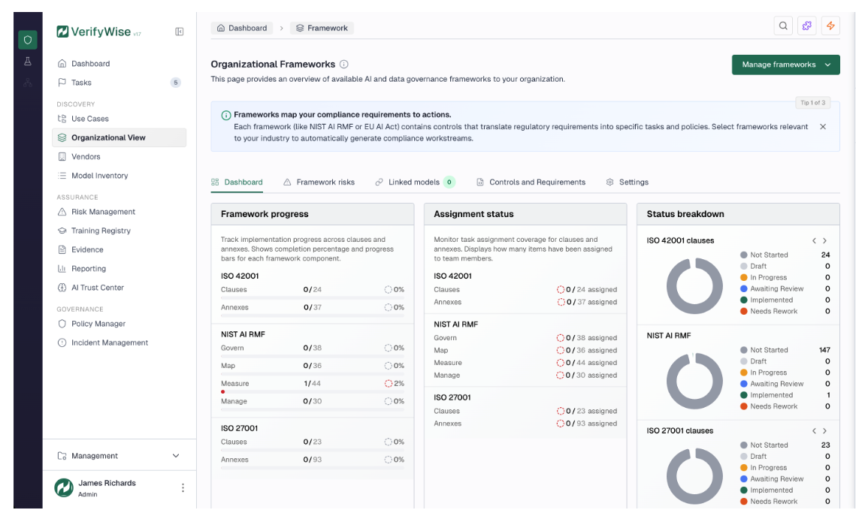

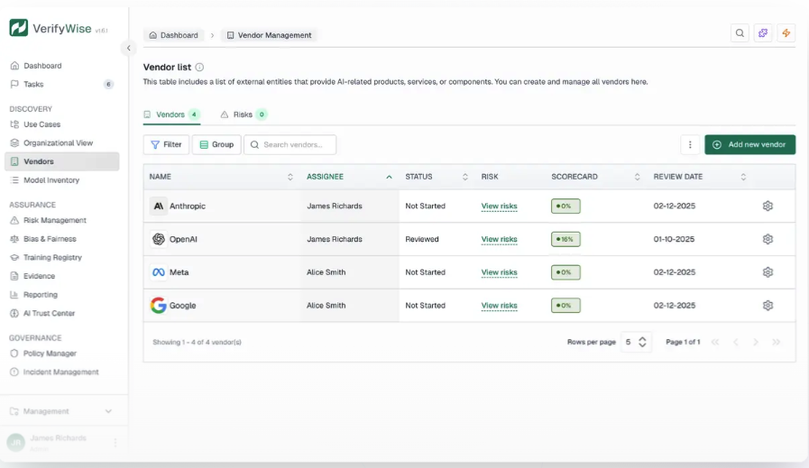

Incident Management
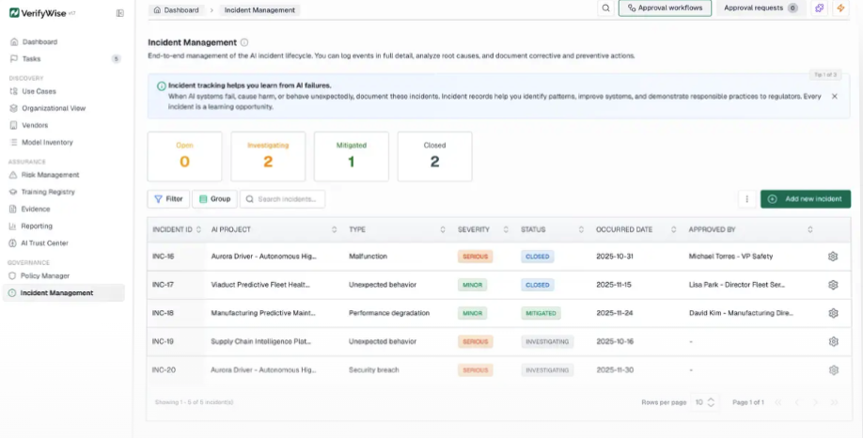

policy-manager
Turn AI governance intentions into documented reality
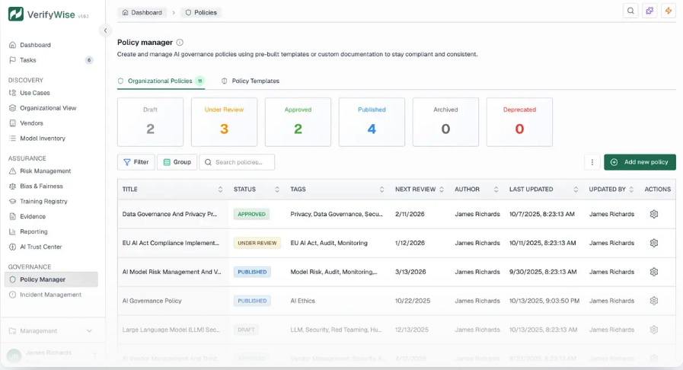
Create, manage, and distribute AI policies with a rich text editor, structured workflows, and complete change history.

